Sediment Fossil Surprise: Why are some fossils found in sediment layers? (Grades 3-5)

Tennessee State Standards Covered
GLE 0307.Inq.1 Explore different scientific phenomena by asking questions, making logical predictions, planning investigations, and recording data
GLE 0307.Inq.2 Select and use appropriate tools and simple equipment to conduct an investigation
GLE 0307.Inq.4 Identify and interpret simple patterns of evidence to communicate the findings of multiple investigations
GLE 0307.5.1 Explore the relationships between an organism's characteristics and its ability to survive in a particular environment
0307.5.2 Investigate the connection between an organism’s characteristics and its ability to survive in a specific environment
0407.5.4 Gather fossil information to draw conclusions about organisms that exist today
GLE 0507.5.2 Analyze fossils to demonstrate the connection between organisms and environments that existed in the past and those that currently exist
0507.5.3 Identify the processes associated with fossil formation
0507.5.4 Use fossil evidence to describe an environment from the past
507.5.5 Use fossils to match a previously existing organism with one that exists today
*Embedded Inquiry is identical for Grades 3-5.

Summary
Students analyze illustrations to understand how a fossil forms. Then they make a model of a fossils found in sediment layers and eat it.

Objective
Students will be able to:
- Draw, label, and create a model of fossils found in sediment layers

Skills Summary
- Creating
- Understanding

National Science Education Standards
- (K-4) Standard D-1: Properties of earth materials

Time
- Approximately 50 minutes
Materials
- Clear cups or bowls
- Edible baking ingredients
- Edible snack foods
- Markers
- Paper
- Pencils
- Scissors
- Spoons
- Transparent tape

Vocabulary
- Fossil: Remnant, impression, or trace of an ancient organism

Background
Scientists use models to help them understand natural processes.

Procedures

- Display the illustrations to show students one way a fossil forms.
- Scroll through the color illustrations and read aloud the captions to help students understand why some fossils are found in sediment layers. Explain that the newest layers are on the top and the oldest layers are on the bottom. Scientists study these layers to determine the age of the rock and the fossils within. Tell students they are going to make an edible model of fossils found in sediment layers.
- Have students draw their models
- Provide each student with a cup or bowl, drawing paper, and a pencil. Have students draw their cup or bowl on a piece of paper. Then ask them to add lines to indicate “sediment layers.” Have students refer to the black-and-white illustration for clues, as needed.
- Have students label their drawings.
- Have students label the top layer “newest” and the bottom layer “oldest.” Then have them draw and label some “sea creatures” in each layer.
- Have students select their ingredients.
- Ask each student to select their ingredients from the variety available. Tell them to choose based on what they will use to represent the sediment layers and sea creatures. For the sea creatures, students can use edible snacks such as raisins, chocolate candies, gummy candies, vanilla wafers, hard candies, or fish-shaped fruit snacks. For the sediment layers, students can use edible ingredients such as coconut flakes, whipped cream, pudding, chilled gelatin, crushed cookies, and decorating sprinkles.
- Have students prepare their fossils.
- Have students use their drawings as guides to build their models. Have them make animals from selected ingredients. For example, students can add food coloring to vanilla wafers to represent an ammonite or shark tooth. They can cut fish-shaped fruit snacks into the shapes of prehistoric sea creatures.
- Have students build models.
- Ask students to spread a layer of sediment ingredients and add some sea creatures in their bowl or cup. Then have them repeat, using different materials for each layer.
- Allow students time to enjoy their treats and discuss the activity.
- Allow students time to eat the model. As they eat, encourage them to notice the different layers and where they find the fossils within them.

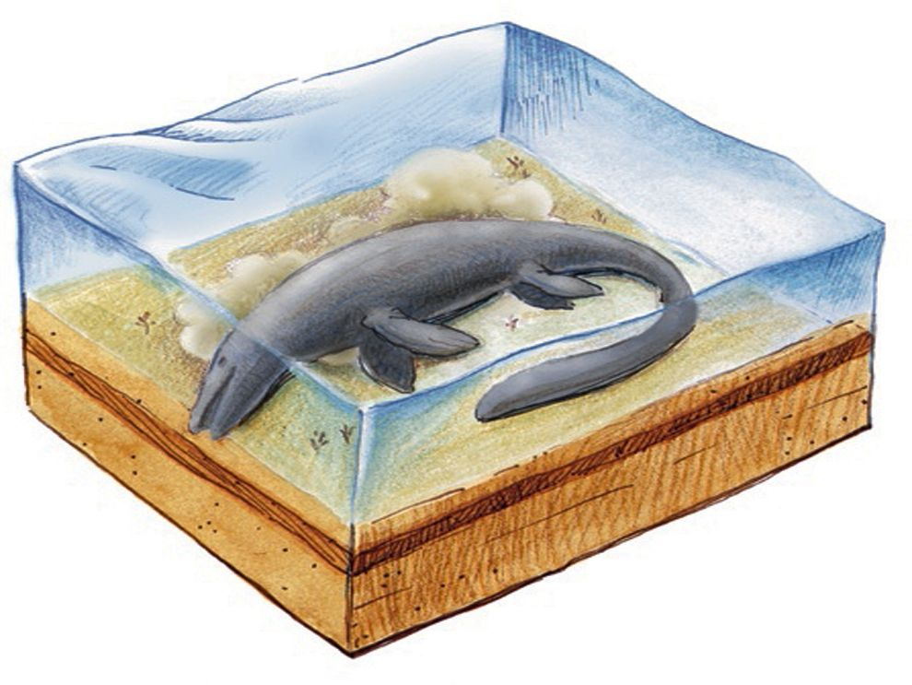 | 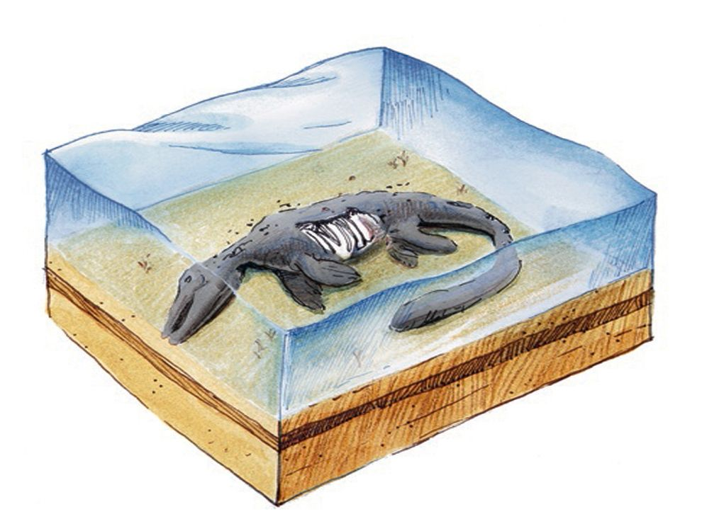
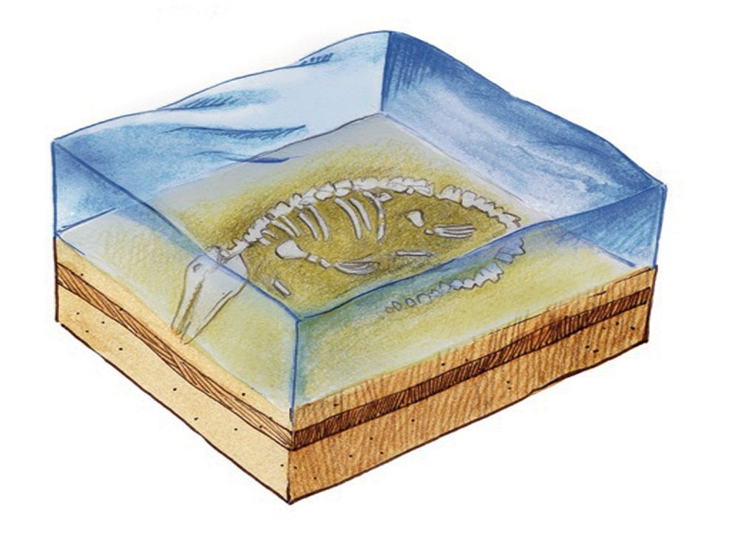 | 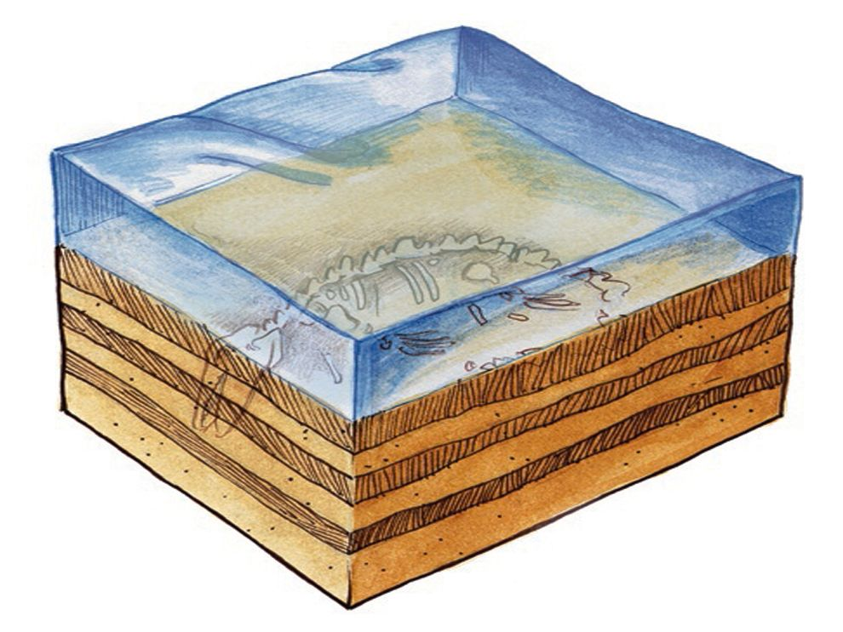
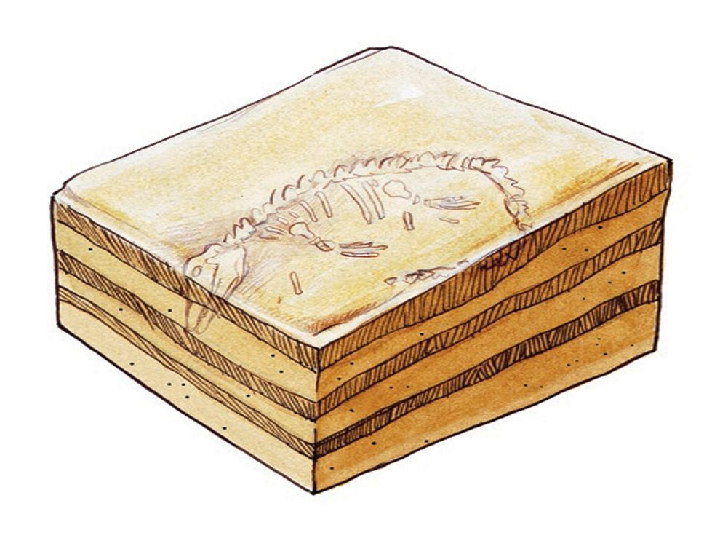 | 